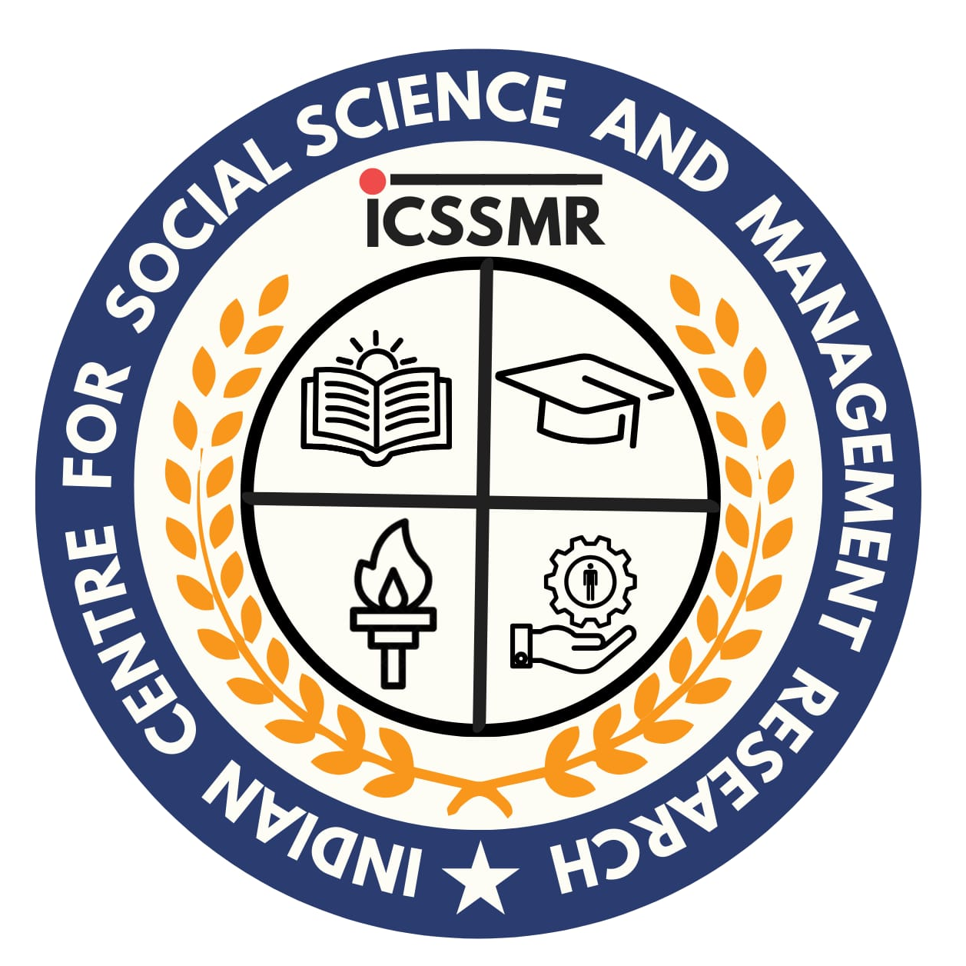

Indian Centre for Social Science and Management Research - ICSSMR Research Proposal Format
Proposal Format – Sustainable Development and Social Well-Being (2026-27)
Note: Applicants must adhere to the word limit specified in each section, and any deviation from the prescribed ICSSMR proposal format will result in the cancellation of the application.

Sl. | Particulars | Details
Title of the Research Project
Write a concise and meaningful title reflecting the research theme.

 | Abstract / Concept Note (Maximum 1000 words) | • Background of the study  • Problem statement  • Objectives  • Methodology  • Expected outcomes
 | Introduction and Rationale of the Study | • Background of the research problem  • Importance of the topic  • Relevance to sustainable development  • Context of the study in India
 | Review of Literature  Discuss major research studies related to your topic  (approx. 500 words) | • Theoretical perspectives  • Key empirical findings  • Limitations of existing studies
Objectives of the Study
List the main objective and specific objectives.
(approx. 800 words)
 | Research Questions / Hypotheses
 | Research Methodology  (approx. 500 words) | • Geographical area  • Population to be studied  • Sample size and sampling technique
 | Study Area and Target Population | • Geographical area  • Population to be studied  • Sample size and sampling technique
Sl. | Particulars | Details
 | Expected Outcomes  (approx. 300 words) | • Academic contributions  • Policy recommendations  • Community benefits
 | Policy Relevance  (Approx. 500 words) | • Sustainable development policies  • Government programmes  • SDGs
 | Total Grant Amount expected for this study | • Research Staff  • Fieldwork & Travel  • Equipment / Software / Books  • Workshops / Dissemination  • Contingency  Amount (in figures): ___________________________ (in ₹)  Amount (in words): ___________________________
References
Follow APA 7th Edition format.

 | Milestones set for
  Phase | Activities | Timeline
  Phase 1 | Literature Review & Research Design | Month 1–3
  Phase 2 | Data Collection | Month 4–9
  Phase 3 | Data Analysis | Month 10–14
  Phase 4 | Report Writing | Month 15–18
 | Research Team Composition
  Name | Designation | Role in Project | Institution
  Project Director
  Co-Project Director
  Member 1
  Member 2
  Member 3

